**Leader Overview**

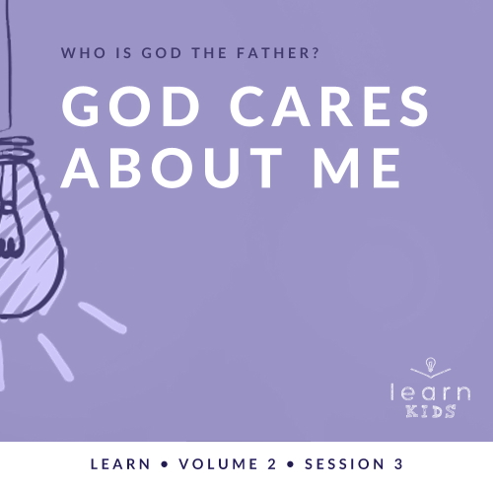

**Who is God the Father?**

*God the Father chose to reveal who He is throughout His Word. A robust picture of God can be seen by looking at His interactions with men and women like us. Since people first sinned in* [*Genesis 3*](https://ref.ly/logosref/Bible.Ge3)*, every generation has had to connect with our invisible God for themselves. Through these sessions about God, you have the opportunity to pass on this life-changing relationship to kids*.

**God Cares about Me**

*God is our Heavenly Father, and He intently cares for His people far beyond what any earthly parent could. Our Bible story reveals God’s care for King Hezekiah when he was sick, and God healed him. The story shows us that God sees His people. He cares about the big and the small details of our life. When we call out to Him, He listens. He responds when we turn to Him for help*.

**Bible Lesson**

God Shows Hezekiah He Cares

[2 Kings 20:1–11](https://ref.ly/logosref/Bible.2Ki20.1-11); [Psalm 139:16–18](https://ref.ly/logosref/Bible.Ps139.16-18)

**Faith Fact**

My God cares.

**Faith Verse**

[Isaiah 55:8](https://ref.ly/logosref/Bible.Is55.8) (NLT)

“My thoughts are nothing like your thoughts,” says the Lord. “And my ways are far beyond anything you could imagine.”

**Preparing for the Session**

**Leader Preparation Time: 20–25 Minutes**

|  |
| --- |
| ***You Will Need***  ***Large Group***   * *Bible* * *Worship songs (Song suggestions: “Your Love Awakens Me” by Phil Wickham; “Goodness of God” by Bethel Music; “Move” by Jesus Culture; “Faithful Now” by Vertical Worship)* * *For groups not using a phone or tablet only, add:*   *• Projector or TV*  *• Laptop*  *•* ***Faith Fact Slide***  *•* ***Faith Verse Video*** *or* ***Slide***  *•* ***Bible Lesson Video***  *•* ***Teaching Point Slides 1–3***  ***Small Group***   * *Bibles for kids in your group to share* * *Stuffed bear* * ***Small Group Activity Page****, one per kid* * *Pencils or pens, one per kid*   *To access session content from a computer, visit:*  [*BibleEngagementProject.com/downloads*](https://bibleengagementproject.com/Downloads) |
| ***Getting Ready***  ***Large Group***   * *Download videos and slides if needed.* * *Select worship song(s) and have them ready to play.* * *Read the Bible Lesson Scripture to prepare for teaching time.*   ***Small Group***   * *Print copies of the* ***Small Group Activity Page****, one per kid.*   *First time leading* Learn *for Kids? Check out the* [*Facilitator Guide*](https://0b769b0ed3569ef9d18b-f88d8272f61086866d50d048b43ef630.ssl.cf2.rackcdn.com/sites/biblengagementproject/Listen_Facilitator_Guide.pdf)*.* |

**Large Group**

**30 Minutes**

*See what’s needed at the beginning of the session.*

**Introduction**

Welcome! I’m so glad you’re here today! In our time together, we’ll continue to answer this big question: Who is God the Father? So far, we’ve learned that He is the one true God and that He is always in control. Something else about God our Father is that He takes care of us.

**Faith Fact**

Today’s Faith Fact is super simple, but very meaningful. It says **My God cares**.

• *Show the* ***Faith Fact Slide***.

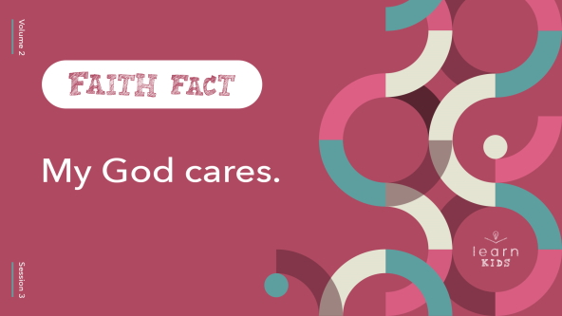

Can you say that with me? **My God cares.** Now put your hand on the last place that hurt on your body. If you had a headache, touch your head. If you had a stomachache, touch your stomach. If you were injured, touch that spot. *(Group response)* Now let’s say the Faith Fact again. **My God cares.** One more time to help us remember. **My God cares.** Great job! No matter where you are hurting, God cares.

**Game**

**Care or Don’t?**

Let’s find out more about each other’s likes and dislikes. In this game, you’ll stand up if you like the thing I say and sit down if you don’t. It’s pretty simple. Don’t follow what your neighbor does. One person might love one thing and another person might dislike it.

• *Read the following things. Then say, “Do you like it?” after each one. If the kids like it, they should stand up. If they don’t like it, they should remain seated*.

• *Keep playing until you run out of items/activities*.

• *Ketchup*

• *Peanut butter*

• *Camping*

• *Jumping off a diving board*

• *Rain*

• *Hiking*

• *Eating at a restaurant*

• *Dancing*

• *Watching sports*

• *Cooking*

• *Taking a nap*

• *Hot dogs*

• *Group projects*

• *Playing video games*

• *Cleaning your room*

I can’t believe some of you don’t like cleaning your room! Thankfully, God doesn’t change His mind. He cares about all of us all the time.

**Worship**

Let’s worship God and thank Him for caring about us. Let’s sing together.

• *Lead the kids in singing one or two praise songs. See suggestions at the beginning of the session*.

**Bible Lesson**

|  |
| --- |
| ***You Will Need***   * *Bible*   *No prep needed for this activity.* |

Thanks for worshipping with me. I know God the Father loves it when we take the time to worship Him. He also loves it when we spend time learning more about Him from His Word. Let’s pray and ask God to reveal something new to us about how much He cares.

**Prayer**

|  |
| --- |
| *Dear God, thank You for caring about us. Help us to care about You enough to spend even more time with You. Amen.* |

**Video Intro**

Before we look at the Bible story, let’s watch this video.

• *Play* ***Bible Lesson Video***.



**Bible Story**

**God Shows Hezekiah He Cares**

Last time, we learned about a message God gave to Jeremiah the prophet. Today, we’ll learn about another message God gave to another prophet named Isaiah. God wanted him to give a message to a king. It was some tough news about what would happen soon. If you want to follow along with our Bible story, open your Bible to [2 Kings 20:1–11](https://ref.ly/logosref/Bible.2Ki20.1-11) first. Then, we’ll read [Psalm 139:16–18](https://ref.ly/logosref/Bible.Ps139.16-18).

• *Read the Bible story aloud to the group*.

• *In order to keep Large Group time moving along, we don’t recommend having the kids read*.

• *Optional: Remind the kids to mark this place with their Bible Bookmark, so they can read it on their own at home*.

**Teaching Time**

Can you believe what happened in that Bible story? God gave Isaiah some very hard-to-hear news to deliver to King Hezekiah, but Hezekiah didn’t just take it. He went straight to God in prayer and begged God to spare his life. God listened and answered Hezekiah’s prayer.

**1. God sees you and cares about the details of your life**.

• *Show the* ***Teaching Point 1 Slide***.

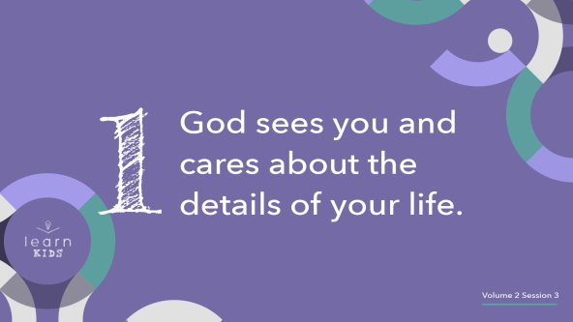

God isn’t only concerned with what we consider the “big” stuff. He wants to be a part of every single detail of your life. Did you know that God cares about even the little details of your life? *(Group response)*

Don’t believe me? I want everyone to do something for me. Count each individual hair on your head. Ready? Go.

• *Wait a few seconds for the kids to start counting then stop them*.

I’m just going to stop you there. It would take you a very long time to count them all because there are about a hundred thousand of them. Plus, some of the hairs would probably fall out between now and when you finished.

Why do you think I asked you to try to count the hairs on your head? *(Allow responses.)* [Luke 12:7](https://ref.ly/logosref/Bible.Lk12.7) tells us that God even knows the number of hairs on our head. That’s how much He cares about the little details in our life. When we know that, it’s easier to believe He cares about the big things, too. That’s what we saw in the Bible story about King Hezekiah.

**2. God listens when we speak to Him**.

• *Show the* ***Teaching Point 2 Slide***.

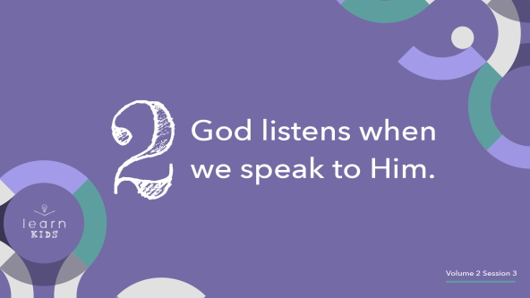

When Isaiah the prophet came to King Hezekiah and told him that he was going to die, what did Hezekiah do just after he heard the news? *(Allow responses.)* That’s right! He turned to God in prayer and cried out to Him.

God didn’t ignore King Hezekiah or just say that His mind was made up. God heard and answered Hezekiah’s prayer. Have you ever prayed and felt like God wasn’t listening? *(Group response)*

Maybe you felt like you were just talking to a brick wall. Instead of looking at me, turn and face a wall. *(Group response)* The funny thing is that’s exactly what King Hezekiah did when he prayed. He turned his face to the wall, but the wall didn’t hear his prayers. God did, and God chose to act right away. He doesn’t always answer our prayers immediately, but He did for Hezekiah that day. God told Isaiah the prophet to turn around and take a second message to King Hezekiah.

**3. God responds when we turn to Him**.

* *Show the* ***Teaching Point 3 Slide***.

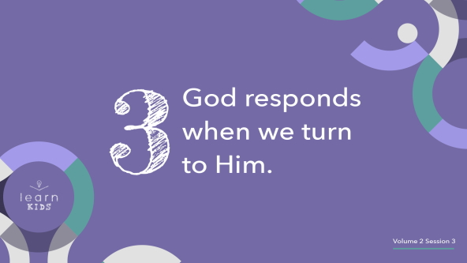

What do you think would have happened if King Hezekiah hadn’t turned to God in prayer? *(Allow responses.)* He probably would have died from the illness. God gave Hezekiah fifteen more years and rescued the whole city from the king of Assyria. Let’s count to fifteen together and imagine all the things that might not have happened or might have happened if Hezekiah had not prayed.

• *Count to fifteen with the kids*.

What things do you think might have happened if King Hezekiah had died? *(Allow responses.)* We’ll never know because God cared enough about King Hezekiah to step in and heal him. Prayer has the power to change things, even big things!

**Prayer and Response**

*Consider playing a worship song softly in the background while kids pray*.

What do you need to turn over to God in prayer and ask Him to do in your life? It could be something big like a family member who needs a miracle. Or it could be something like wanting a new friend. Remember, God cares about all the details of your life. He’s listening to your prayers, and He will respond. His response may not be one you can hear like an audible voice, but He will respond. You might need to look for His response in the Bible. You also could talk with someone wise like King Hezekiah did. Maybe you’ll need to spend time sitting in silence just listening for God to speak.

That’s what we’re going to do now. Close your eyes. I want you to think about what you want God to do in your life—that miracle, someone who needs God, that detail, or whatever it is.

Now, I want you to hold out your hands like I’m handing you something. This shows you want to receive from God. *(Pause for kids to respond.)* Let’s pray.

**Prayer**

• *Optional: Have the kids repeat phrases of the prayer after you*.

|  |
| --- |
| God, I need You. I know there are a lot of people that need You, but I also know that You care about every detail of my life. Please help me with what I am asking You for. Help me to trust that Your plan for my life is best. Help me to know that You are for me. Amen. |

**Faith Verse**

Let’s take another look at our Faith Verse together. It reminds us that God cares about us enough to think about us. He has a plan for each of us.

• *Play* ***Faith Verse Video***.

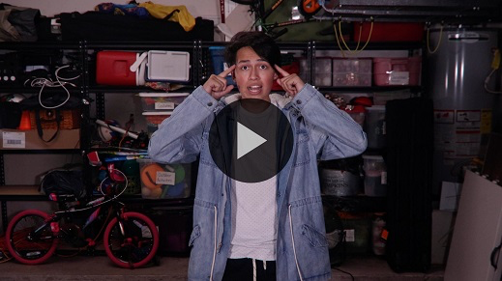

[Isaiah 55:8](https://ref.ly/logosref/Bible.Is55.8) (NLT)

“My thoughts are nothing like your thoughts,” says the Lord. “And my ways are far beyond anything you could imagine.”

**Faith Fact**

How cool is it to know that God the Father actually knows you and thinks about you? Best of all, He cares about you and me.

• *Show the* ***Faith Fact Slide***.



Say our Faith Fact with me. **My God cares.** I hope you’ll remember that God cares about you and that you take the time to show Him you care about Him, too. Spend time with Him every day.

• *Dismiss kids to Small Group time or to go home if your group time ends here*.

**Small Group**

**30 Minutes**

*This section can be done in conjunction with the large group or on its own if you do small groups with your kids. During Small Group time, the goal is to connect the kids with the Word of God and to each other. All activities are led by the small group leader.*

**Group Connection**

**What Does God Care About?**

We’re learning that God cares about all the big and little details in our life. For fun, we’ll share one small thing God cares about in our life with the group. Keep it short. For example, you can say your family or a test you took today. Pay close attention because after everyone has shared, we’ll see if you can remember what everyone said. Are you ready*? (Group response)*

• *Have each kid in the group name one thing*.

Now, we’ll go around the group again to remember what each person said. Let’s stand up. I’ll walk behind the group and stop behind someone. If they remember what I shared correctly, I’ll take their place in the circle, and they’ll choose who goes next. If they can’t remember, I’ll pick someone else. We’ll keep going until everyone has had a chance to remember.

• *Keep playing until everyone has had a chance to remember*.

Isn’t it amazing that God can remember all kinds of things about us? *(Group response)* That’s a lot harder than what we had to remember. Remembering all those things about us is one of the ways God shows us just how much He cares.

**Learn about It**

|  |
| --- |
| ***You Will Need***   * *Bibles for kids in your group to share*   *No prep needed for this activity.* |

**Scripture Search:** [**Psalm 139:16–18**](https://ref.ly/logosref/Bible.Ps139.16-18)**;** [**2 Kings 20:1–3**](https://ref.ly/logosref/Bible.2Ki20.1-3)**;** [**2 Kings 20:4–7**](https://ref.ly/logosref/Bible.2Ki20.4-7)**;** [**2 Kings 20:8–11**](https://ref.ly/logosref/Bible.2Ki20.8-11)

Let’s dig deeper into God’s Word and see what else He has to say to us. As we find and read each of these verses, let’s consider: What does this Scripture mean for our life today?

• *Give each kid a Bible and search for one or more of the Scriptures as a group together (as time allows). When everyone has found the Scripture, have one of the kids read it. Then, answer the questions about it*.

• *Pair kids who need additional help with older kids. Kids will get better finding Scriptures the more they practice*.

• *Optional: Make this a competition to see who can find the Scripture first*.

**Bible Reading Tip**

Here’s a Bible reading tip. You might think that you’ve heard all the stories in the Bible. Think again! If you’re feeling like you need something new or different to read, try switching things up. Read from a book of the Bible that you don’t normally read. Write down some of the new things you learn.

**Challenge**

Every time you feel like things aren’t going your way this week, take a moment and say the Faith Fact to yourself. Maybe there will be times when you’re frustrated or tired or even need God to heal you like King Hezekiah did. Stop what you’re doing and say the Faith Fact.

**Faith Fact**

Let’s do that now. Say it with me: **My God cares**.

**Group Discussion**

*Feel free to use all or just a few questions as a jumping-off place for good discussion. Questions marked with * are designed for more conversation. Adjust the questions based on the age or maturity of your group. Typically, older kids will be able to dive a little deeper than younger ones*.

**Questions**

• *If small group activities are not immediately following Large Group time, you may want to read the Bible story passage before this discussion*.

Who was the prophet God sent to deliver a message to King Hezekiah?

What was the first message from God?

What did King Hezekiah do after he heard the message from God?

What happened after King Hezekiah prayed?

* Do you believe that God cares about you? Why or why not?

* How would you tell someone else that God cares about them?

* Who is an example of someone in the Bible whom God rescued because He cared about them?

* When should you turn to God in prayer?

* What is one way you can hear a response from God?

**Prayer Requests**

*Finish group discussion by sharing prayer requests and praise reports. Keep track of your small group’s prayer requests and review them each time you meet*.

**Prayer**

*Have kids pray for each other’s prayer requests*.

**Faith Verse Review**

|  |
| --- |
| ***You Will Need***   * *Stuffed bear*   *No prep is needed for this activity.* |

Our Faith Verse reminds us that God’s thoughts and ways are different from ours, but that doesn’t mean He doesn’t care about us when things don’t go our way. Let’s do the actions for the Faith Verse together.

• *Show* ***Faith Verse Video***.



[Isaiah 55:8](https://ref.ly/logosref/Bible.Is55.8) (NLT)

“My thoughts are nothing like your thoughts,” says the Lord. “And my ways are far beyond anything you could imagine.”

**Faith Verse Fun**

**Caring Bear Pass**

We are going to pass this “caring bear” around the circle. Each time you get it, you’ll have to say the next word in the Faith Verse. Let’s see if we can make it all the way to the end of the Faith Verse together one word at a time!

• *Repeat the verse a few times*.

• *Optional: Go faster each time as the kids get better at saying the verse*.

**Activity Page**

**A Prayer a Day**

|  |
| --- |
| ***You Will Need***   * ***Small Group Activity Page****, one per kid* * *Pencils or pens, one per kid*   ***Getting Ready***   * *Print copies of the* ***Small Group Activity Page****, one per kid.* |

Remember, God cares about us and wants to hear from us. He heard and responded to King Hezekiah’s prayers. He is listening and will respond to your prayers, too.

• *Give each kid a copy of the* ***Small Group Activity Page*** *and a pencil*.

God doesn’t always answer right away like He did for King Hezekiah, so it’s a good idea to write down what you’re praying for. That’s what you’re going to do on this prayer list. Take a few moments and think about what you are praying for. Then, write down your prayer needs.

• *Let kids make their prayer lists*.

• *Help them with spelling and ideas as needed*.

• *If you have a special prayer need in your kids group or church, encourage kids to add it to their prayer list*.

**Dismissal**

I had a great time learning more about God the Father with you today. Let’s close in prayer.

**Prayer**

|  |
| --- |
| *Dear God, thank You for caring about us enough to listen to our prayers and respond. Amen.* |

**Faith Fact Recap**

• *Show the* ***Faith Fact Slide***.



One important thing I want you to remember from today is our Faith Fact. Let’s say it together one more time. **My God cares.** I’m glad you came today. I can’t wait to see you next time.

• *Send home the* ***Small Group Activity Page***.

• *Remind parents that there are* ***Family Devotions*** *available on the app to do with their kid*.

• *Tell everyone the date and time for the next session*.